Insert your name, centre number and candidate number into the header above.
Save this evidence document as evidence_ followed by your centre number_ candidate number. For example: evidence_ zz999_9999
Screenshots or program listings must be copied into appropriate cells in the following tables.
Examiners must be able to read the contents including any screenshots without the use of a magnifying glass. Answers that are not readable or missing will not be awarded any marks.
Save this evidence document at regular intervals, for example, every 10 minutes.
Question 1
Part 1(a)
class node:
def __init__(self, theData, nextNodeNumber):
self.data = theData
self.nextNode = nextNodeNumber

Part 1(b)
linkedList = [node(1,1),node(5,4),node(6,7),node(7,-1),node(2,2),node(0,6),node(0,8),node(56,3),node(0,9),node(0,-1)]
startPointer = 0
emptyList = 5

Part 1(c)(i)
def outputNodes(linkedList, startPointer):
currentPointer = startPointer
while (currentPointer != -1):
print(str(linkedList[currentPointer].data))
currentPointer = linkedList[currentPointer].nextNode

Part 1(c)(ii)
Code:
outputNodes(linkedList, startPointer)

Screenshot:
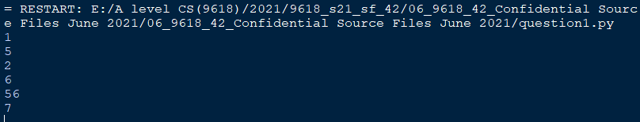

Part 1(d)(i)
def addNode(linkedList, startPointer, emptyList):
dataToAdd = input("Enter the data to add")
if emptyList < 0 or emptyList > 9:
return False
else:
emptylistpointer = linkedList[emptyList].nextNode
newNode = node(int(dataToAdd), -1)
linkedList[emptyList] = (newNode)
previousPointer = 0
currentPointer = startPointer
while (currentPointer != -1):
previousPointer = currentPointer
currentPointer = linkedList[currentPointer].nextNode
linkedList[previousPointer].nextNode = emptyList
emptyList = emptylistpointer
return True

Part 1(d)(ii)
linkedList = [node(1,1),node(5,4),node(6,7),node(7,-1),node(2,2),node(0,6),node(0,8),node(56,3),node(0,9),node(0,-1)]
startPointer = 0
emptyList = 5
print("Before addnode")
outputNodes(linkedList, startPointer)
returnValue = addNode(linkedList, startPointer, emptyList)
if returnValue == True:
print("Item successfully added")
else:
print("Item not added, list full")

print("After addnode")
outputNodes(linkedList, startPointer)

Part 1(d)(iii)
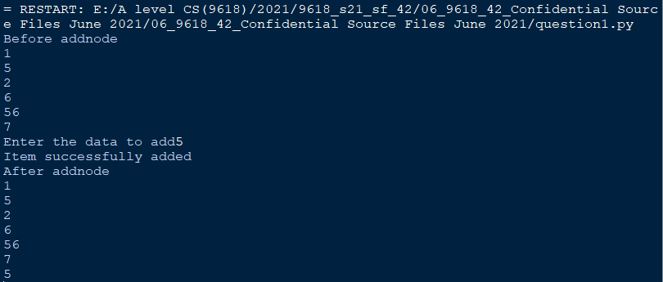

Question 2
Part 2(a)
global arrayData
arrayData = [10, 5, 6, 7, 1, 12, 13, 15, 21, 8]

Part 2(b)(i)
def linearSearch(searchValue):
global arrayData
for x in range(0, 10):
if arrayData[x] == searchValue:
return True
return False

Part 2(b)(ii)
arrayData = [10, 5, 6, 7, 1, 12, 13, 15, 21, 8]
searchValue = int(input("Enter the number to search for "))
returnValue = linearSearch(searchValue)
if returnValue == True:
print("It was found")
else:
print("It was not found")

Part 2(b)(iii)
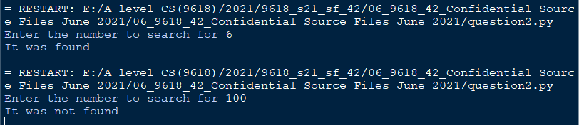

Part 2(c)
def bubbleSort():
global arrayData
for x in range(0,10):
for y in range(0,9):
if arrayData[y] < arrayData[y + 1]:
temp = arrayData[y]
arrayData[y] = arrayData[y + 1]
arrayData[y + 1] = temp

Question 3
Part 3(a)
class TreasureChest:
#Private question : String
#Private answer : Integer
#Private points : Integer
def __init__(self, questionP, answerP, pointsP):
self.__question = questionP
self.__answer = answerP
self.__points = pointsP

Part 3(b)
#arrayTreasure(5) as TreasureChest
arrayTreasure = []
def readData():
global arrayTreasure
filename = "TreasureChestData.txt"
try:
file = open(filename, "r")
dataFetched = (file.readline()).strip()
while (dataFetched != ""):
question = dataFetched
answer = (file.readline()).strip()
points = (file.readline()).strip()
arrayTreasure.append(TreasureChest(question, answer, points))
dataFetched = (file.readline()).strip()
file.close()
except IOError:
print("Could not find file")

Part 3(c)(i)
def getQuestion(self):
return self.__question

Part 3(c)(ii)
def checkAnswer(self, answerP):
if int(self.__answer) == answerP:
return True
else:
return False

Part 3(c)(iii)
def getPoints(self, attempts):
if attempts == 1:
return int(self.__points)
elif attempts == 2:
return int(self.__points)//2
elif attempts == 3 or attempts == 4:
return int(self.__points)//4
else:
return 0

Part 3(c)(iv)
readData()
choice = int(input("Pick a treasure chest to open"))
if choice > 0 and choice < 6:
result = False
attempts = 0
while result == False:
print(arrayTreasure[choice-1].getQuestion())
answer = int(input("Enter the answer: "))
result = arrayTreasure[choice-1].checkAnswer(answer)
attempts = attempts + 1
print(int(arrayTreasure[choice-1].getPoints(attempts)))

Part 3(c)(v)
